|  |
| --- |
| University of Regina |
| TelPort User Guide |
| Version 1.0 |

|  |
| --- |
| Dakota Fisher Quinn Bast  April 8, 2019 |

Contents

Accessing TelPort 2

Logging Out 2

Logging In 3

Warning messages 3

Viewing Call Logs 4

Viewing Feature Access Codes 5

Configuring Phone Services 6

Enabling a Service 6

Disabling a Service 6

Successful update of a Service 6

Missing a Required Service Setting 6

Configuring a Service 7

Information Popovers 7

Phone Footer 8

Making a Phone Call 8

Receiving a Phone Call 8

Mute the Microphone 8

# Accessing TelPort

To access TelPort, visit [telport.me](https://telport.me) on any desktop or mobile phone internet browser. Once the web application has loaded, you will be greeted by a login page. 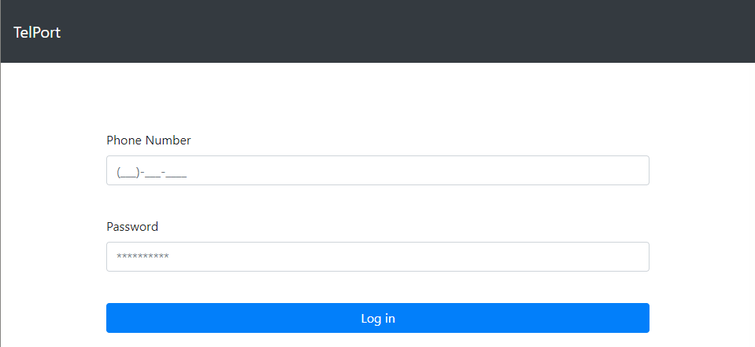

# Logging Out

To log out of the application, click the “Sign out” button in the navigation bar. You will be redirected to the login page where you can sign in again if interested. You must be logged in to see the “Sign out” button.



# Logging In

To log in, enter your SaskTel phone number, and the password associated with it in the log in fields, and press the “Log in” button.

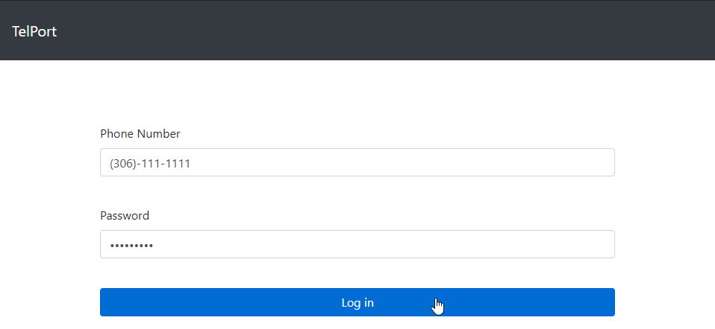

## Warning messages

If the entered phone number isn’t a ten-digit phone number, a warning message will appear around the phone number field.

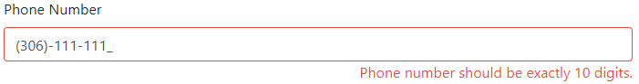

If a password isn’t entered, then a warning message will appear around the password field.

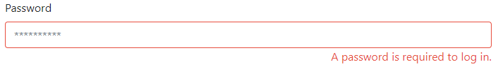

If the login failed, due to server issues, or invalid credentials such as a bad password, or an incorrect phone number, then a message will appear above the login form.

https://i.imgur.com/EXMEkg8.png

# Viewing Call Logs

To view the call logs associated with the number used to log in, click the “Call Logs” button in the navigation bar. You must be logged in.



This will bring up the call logs popup, which provides a sortable table view of incoming, out going, and missed calls.

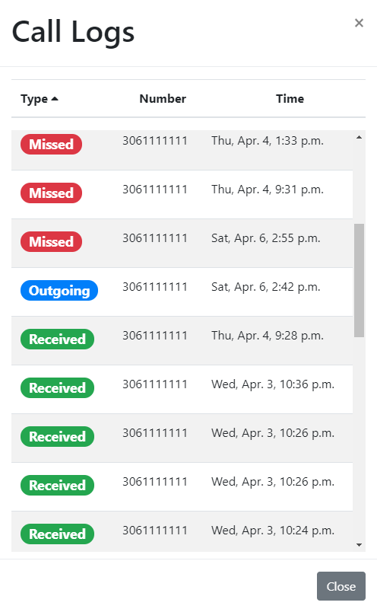

To sort the call logs, click Type, Number, or Time at the top of the table to sort in descending, or ascending order.

To close the Call Logs, click anywhere outside of the popup, the ‘x’ in the upper right corner or, the “Close” button.

# Viewing Feature Access Codes

To view the feature access codes, click the “Feature Access Codes“ button in the navigation bar. This provides a list of star codes that can be used from any telephone to customize phone services. You must be logged in.



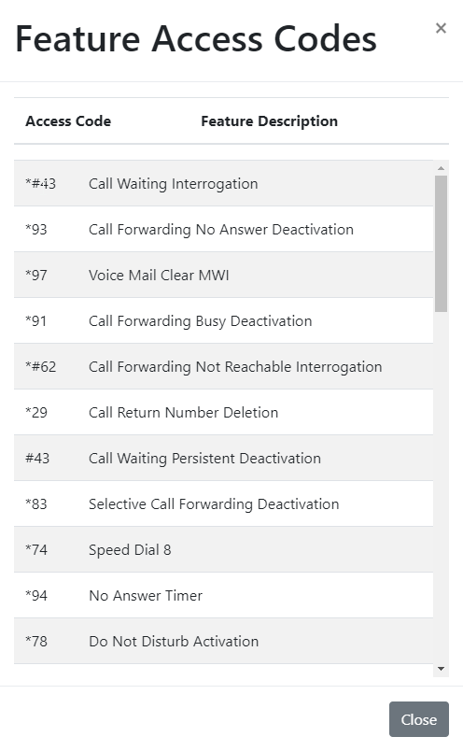

To close the feature access codes, click anywhere outside of the popup, the ‘x’ in the upper right corner or, the “Close” button.

# Configuring Phone Services

To configure a phone service, there are a few choices. Each phone service that is added to your account is displayed in a list on the main page.

## Enabling a Service

To enable a service from the main page, simply slide the toggle button in the corresponding row to the right side on position so that it is blue.



## Disabling a Service

To disable a service from the main page, simply slide the toggle button in the corresponding row to the left side off position so that it is grey.

https://i.imgur.com/aMY6XCQ.png

## Successful update of a Service

When enabling or disabling a service, if the update is successful, then a success message will appear at the bottom of the screen notifying you of the update.

https://i.imgur.com/2YrR63e.png

## Missing a Required Service Setting

When enabling a service, all the required features must be configured. If a feature is missing, then a warning message will appear notifying you of the missing information.



## Configuring a Service

To configure a service, click the “Configure” button next to the enable toggle for the desired service. This will slide over to a customization window and present every feature to be configured for the selected feature.

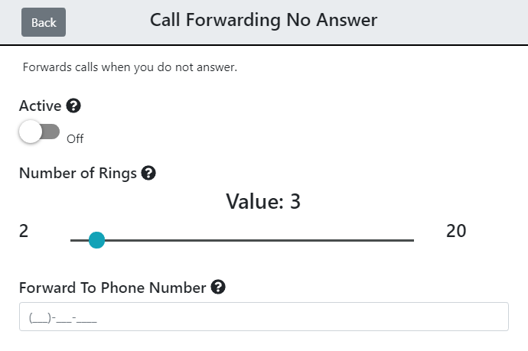

In the above image, the call forwarding no answer service can be enabled or disabled, the number of rings before forwarding on no answer can be selected with a slider, and the number to forward to is configurable as the last option.

To return to the main page, click the “Back” button in the upper left corner.

## Information Popovers

Every element that describes a feature of a service has a hover able information popover.



# Phone Footer

The bottom of the web application is a browser phone. Because you’ve signed in using your SaskTel phone service, you can make and receive calls through the browser using this number just as you would from your physical device while logged in.



## Making a Phone Call

To make a phone call, type a phone number in the text field and click “Call”.



Once clicked, the phone will begin to ring until the recipient responds. You can always end a call at any time by pressing the “End” button.



## Receiving a Phone Call

When you begin to receive an incoming phone call, the footer of the application will change to an “Answer” button. To answer the incoming call, click the “Answer” button.



## Mute the Microphone

The microphone can be muted by clicking on the microphone symbol next to the call duration. This can be undone by clicking on it again to turn the microphone back on.

